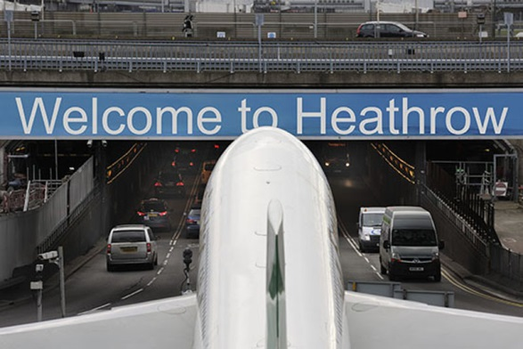

New Passive Fire Protection Product Wins Prestigious Heathrow Refurbishment.

A new entrant to the passive fire protection world branded PassiveTec® has been awarded the prestigious refurbishment of Heathrow's tunnels.

The product is owned by a joint venture between (SIG Plc), a £2.6bn company, which is Europe's largest distributor of specialist construction materials, and PFP Fire Systems, a group of experienced fire protection engineers.

PassiveTec® fire boards have been used both as soffit lining and wall cladding to provide a complete RWS standard of protection in both the main tunnels and cargo tunnel. The highly innovative solution using the thinnest RWS rated board globally, at just 24mm, was praised by Nick Beedle, Head of Operations at VVB Engineering Services, who are the project's M&E contractors.

He said: "This is a cost efficient, visually attractive installation created from a world-class product and a collaborative approach from PassiveTec."

Simon Burgess, Director at SIG Plc said: "This is a highly important strategic move for us as we build our presence in the global infrastructure market. Our own brand and service model offer tunnel contractors genuine choice when they select their passive fire protection partners."

The contract is for the refurbishment of two lane inbound/outbound tunnels, along with side bores and a cargo tunnel on the air side.

Due for completion later in 2016, it is part of a significant upgrade of infrastructure and fire safety at Europe's busiest airport.

Simon MacDonald, PFP Fire Systems Managing Director said: "The win is a highly significant event for fire protection in tunnels worldwide that will alter the competitive context permanently for the benefit of all connected to the industry."